Project Two README

Nick Allen

CS-340

December 16, 2023

**About the Project**

The purpose of this project is to create a dashboard in Jupyter Notebook to visualize data in a database of animals who may be suited for rescue work based on the client’s criteria.

**Motivation**

The motivation of this dashboard is to create a way for the client to easily filter and visualize the data needed in Austin Animal Shelter’s database of animals using the Dash framework for the structure of the web application.

**Getting Started**

What you need:

* Python 3.6 or higher.
* Windows PowerShell.
* Docker.
* Jupyter Notebook.
* CRUD module.
* .ipnyb template for the dashboard.

**Installation/ Usage**

1. Install Docker, create account and a new container.
2. Upload desired data to container, then run it.
3. Ensure Python CRUD module is in the same directory as the .ipnyb template file on your system.
4. Using PowerShell, run Jupyter notebook with “Jupyter notebook” command.
5. Access Jupyter template file through Jupyter notebook directory, update username and password fields associated with the CRUD module.
6. Import CRUD module to the ipnyb template file with the correct file and class name.
7. Connect to Docker database using via the CRUD module.
8. Adjust layout, controller, widgets and other components as desired for filtering and visualizing data.
9. Run cell.

Functionality Screenshots:  
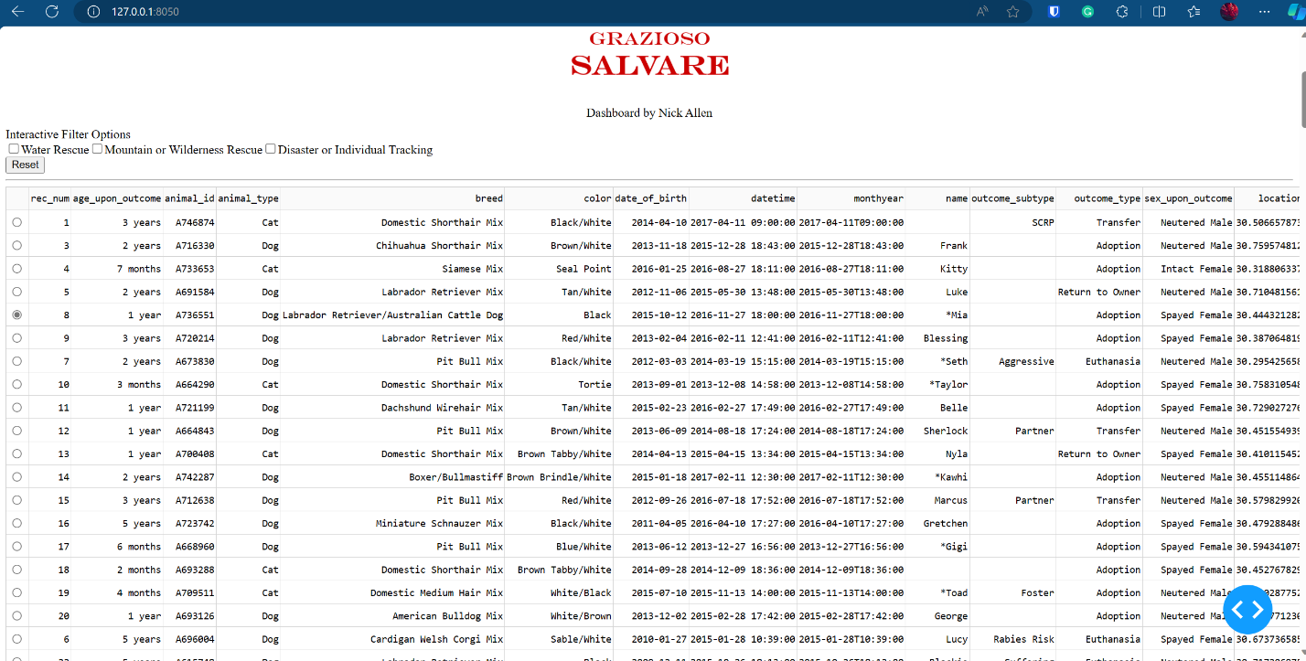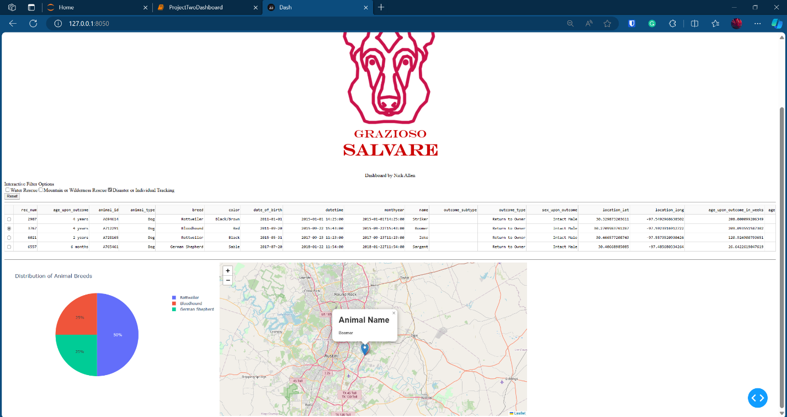

Video Example:  


**Roadmap**

Current Features:

* Default view of unfiltered animal data for Austin Animal Shelter
* Filters for sorting animals into categories for each type of rescue scenario – water rescue, mountain or wilderness rescue, disaster or individual tracking.
* Reset button for reverting data and graphs back to unfiltered state. Unchecking the filtered category also resets the graphs.
* Pie graph for visualizing the breed distribution of each category of rescue animals.
* Geo tracker for locations of each individual animal, with selectable rows.

Known Issues:

* Credentials are hard coded into the module providing a security risk.
* Credentials are hard coded into .ipny template file.

**Challenges Encountered:**

* Main challenge during the completion of the template file was ensuring that the appropriate row was selected, and correct indexing for each column of data in the rows.

**Contact:**

Nick Allen